**[29] Design DFA Which Should Accepts Strings**

* **BCAAAAAAAAAAA**
* **BC**
* **C**

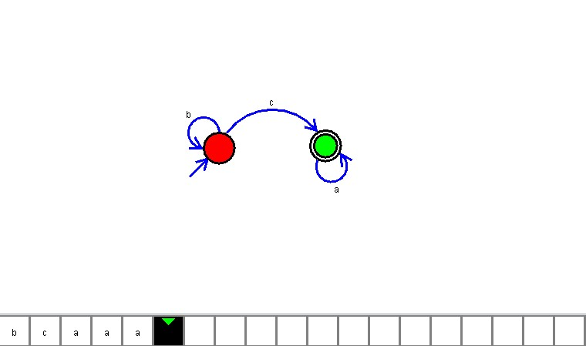

**Result**

The DFA is designed to compute the given strings as input using AutoSim tool